### **CHAPTER 5: FEATURE DETECTION AND DESCRIPTORS**

| **5.1 Corner and Blob Detection** |
| --- |
| **5.2 Feature Descriptors** |
| **5.3 Feature Matching** |

**5.1 Corner and Blob Detection**

Corner and blob detection are both computer vision techniques used to extract features from images:

Corner detection

Used to identify corners in an image, and is often used in motion detection, image registration, and object recognition. Corner detection works by placing a small window over an image and observing the change in intensity when the window is moved.

Blob detection

Used to identify regions in an image that are different from their surroundings, such as regions with different colors or brightness. Blob detection is often used in object recognition, tracking, and facial recognition.

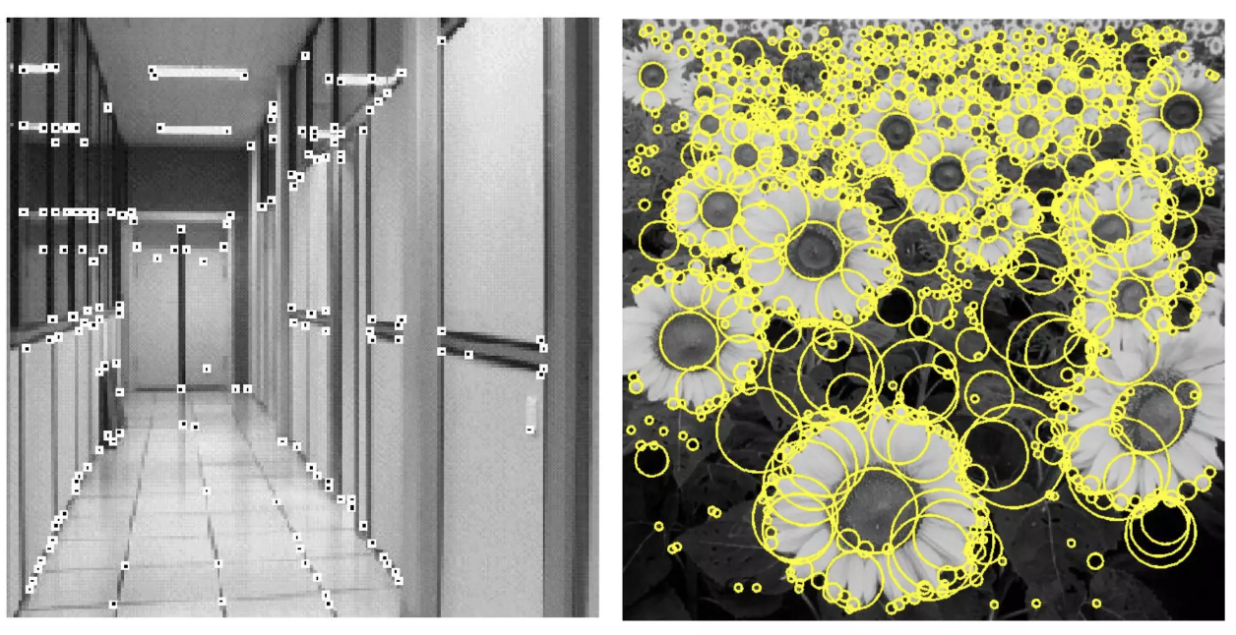

**5.1.1 Corner Detection**

**Corner**

A corner is a point whose local neighborhood stands in two dominant and different edge directions. In other words, a corner can be interpreted as the junction of two edges, where an edge is a sudden change in image brightness. Corners are the important features in the image, and they are generally termed as interest points which are invariant to translation, rotation, and illumination.

So let's understand why corners are considered better features or good for patch mapping. In the above figure, if we take the flat region then no gradient change is observed in any direction. Similarly, in the edge region, no gradient change is observed along the edge direction. So both flat region and edge region are bad for patch matching since they not very distinctive (there are many similar patches in along edge in edge region). While in corner region we observe a significant gradient change in all direction. Due this corners are considered good for patch matching(shifting the window in any direction yield a large change in appearance) and generally more stable over the change of viewpoint.

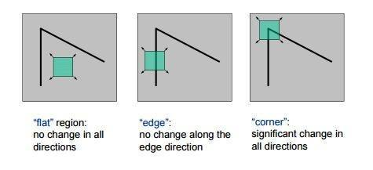

**Corner Detection: Harris Corner Detection**

The idea is to consider a small window around each pixel p in an image. We want to identify all such pixel windows that are unique. Uniqueness can be measured by shifting each window by a small amount in a given direction and measuring the amount of change that occurs in the pixel values.

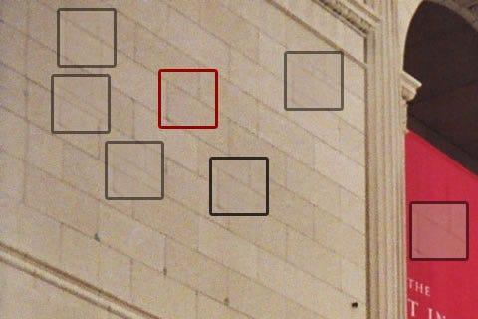

More formally, we take the sum squared difference (SSD) of the pixel values before and after the shift and identify pixel windows where the SSD is large for shifts in all 8 directions.

Let us define the change function E(u,v) as the sum of all the sum squared differences (SSD), where u,v are the x,y coordinates of every pixel in our 3 x 3 window and I is the intensity value of the pixel. The features in the image are all pixels that have large values of E(u,v), as defined by some threshold.

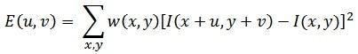

We have to maximize this function E(u,v) for corner detection. That means, we have to maximize the second term. Applying Taylor Expansion to the above equation and using some mathematical steps, we get the final equation as:

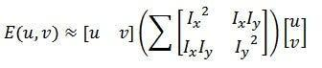

Now, we rename the summed-matrix, and put it to be M:

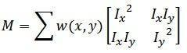 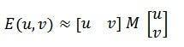Remember that we want the SSD to be large in shifts for all eight directions, or conversely, for the SSD to be small for none of the directions. By solving for the eigenvectors of M, we can obtain the directions for both the largest and smallest increases in SSD. The corresponding eigenvalues give us the actual value amount of these increases. A score, R, is calculated for each window:

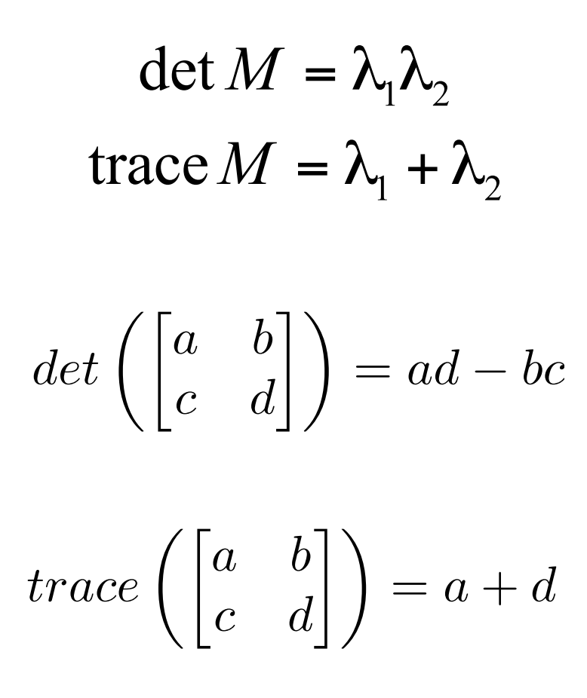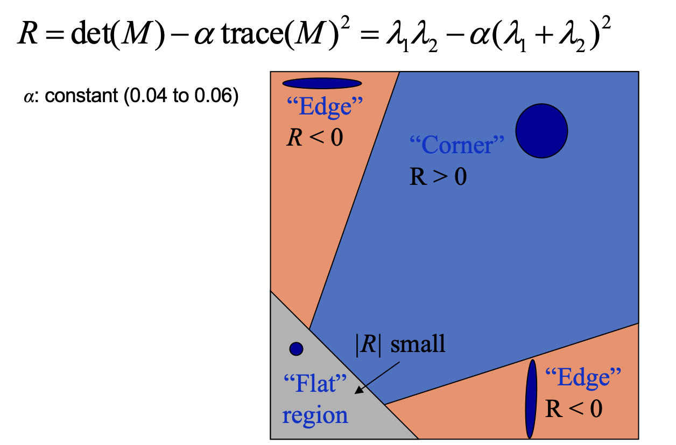

λ1 and λ2 are the eigenvalues of M. So the values of these eigenvalues decide whether a region is a corner, edge or flat.

When |R| is small, which happens when λ1 and λ2 are small, the region is flat.

When R<0, which happens when λ1>>λ2 or vice versa, the region is an edge.When R is large, which happens when λ1 and λ2 are large and λ1∼λ2, the region is a corner.

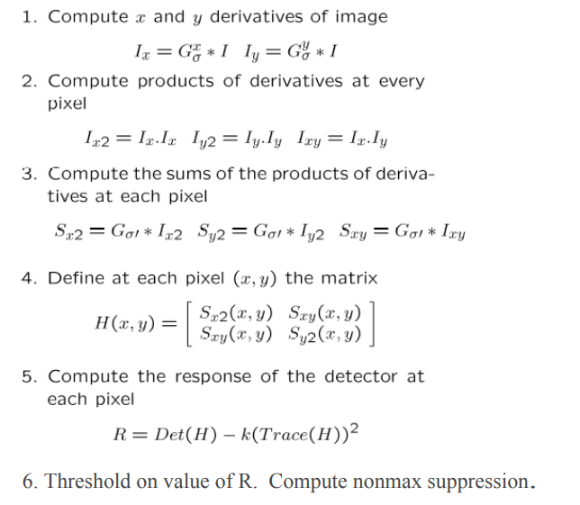

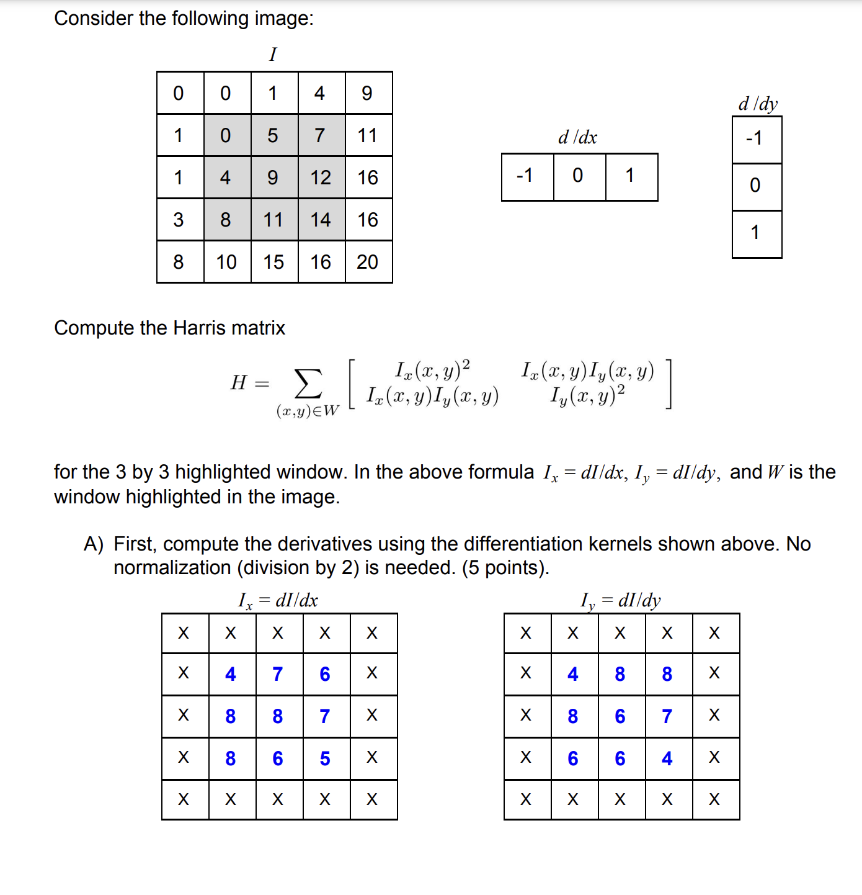

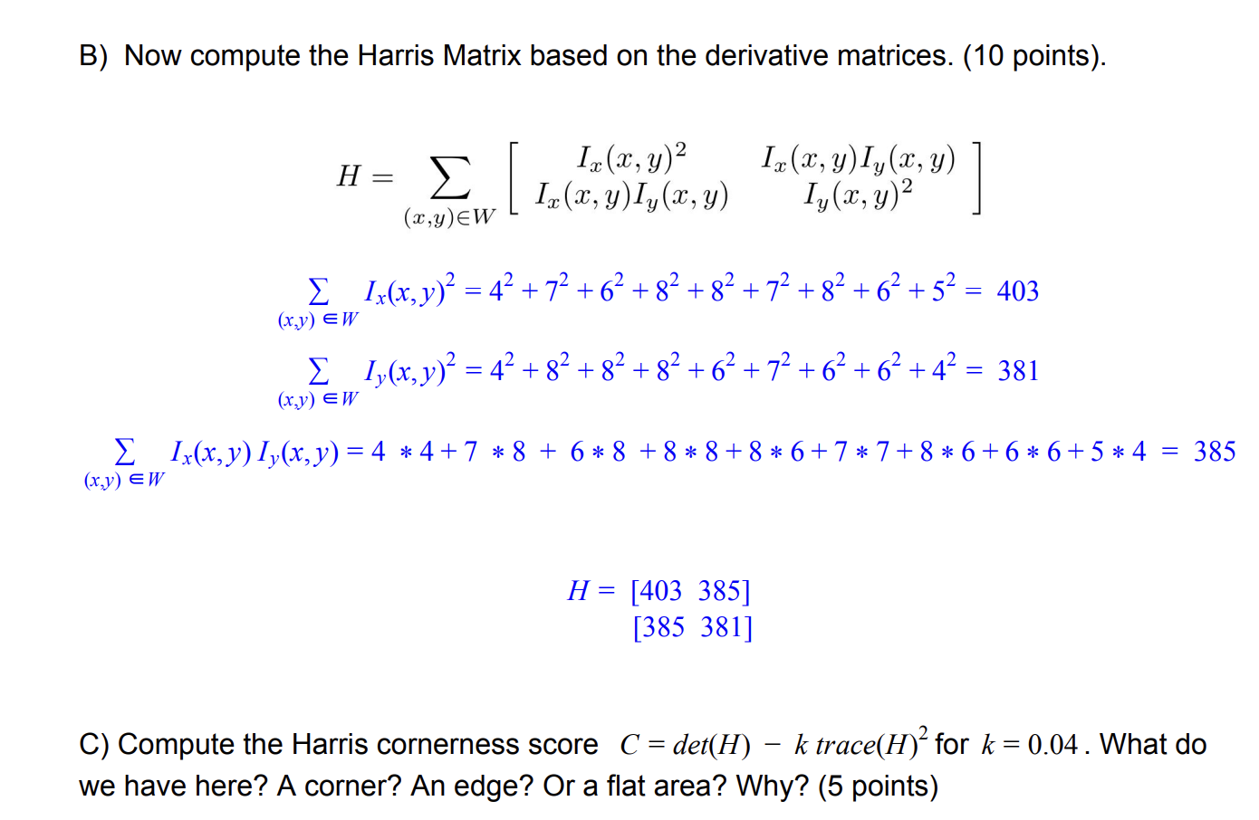

det(H)=Ix(x,y)2Iy(x,y)2 - (Ix(x,y)Iy(x,y))2

det(H)=(405 x 381)-(385 x 385)= 5318

trace(H)=Ix(x,y)2 + Iy(x,y)2 =784

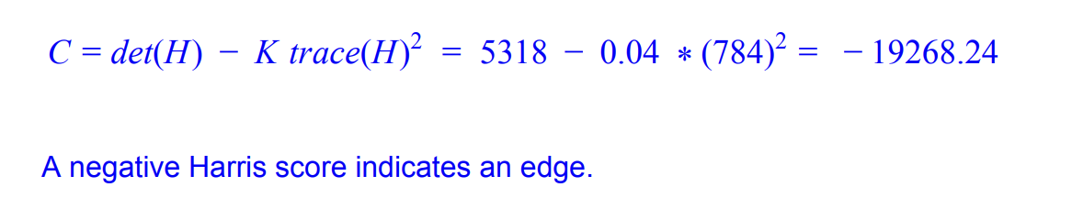

| import numpy as np  import cv2 as cv  filename = 'chessboard.png'  img = [cv.imread](https://docs.opencv.org/3.4/d4/da8/group__imgcodecs.html#ga288b8b3da0892bd651fce07b3bbd3a56)(filename)  gray = [cv.cvtColor](https://docs.opencv.org/3.4/d8/d01/group__imgproc__color__conversions.html#ga397ae87e1288a81d2363b61574eb8cab)(img,cv.COLOR_BGR2GRAY)  gray = np.float32(gray)  dst = [cv.cornerHarris](https://docs.opencv.org/3.4/dd/d1a/group__imgproc__feature.html#gac1fc3598018010880e370e2f709b4345)(gray,2,3,0.04)  #result is dilated for marking the corners, not important  dst = [cv.dilate](https://docs.opencv.org/3.4/d4/d86/group__imgproc__filter.html#ga4ff0f3318642c4f469d0e11f242f3b6c)(dst,None)  # Threshold for an optimal value, it may vary depending on the image.  img[dst>0.01*dst.max()]=[0,0,255]  [cv.imshow](https://docs.opencv.org/3.4/df/d24/group__highgui__opengl.html#gaae7e90aa3415c68dba22a5ff2cefc25d)('dst',img) |
| --- |

**5.1.2 Blob Detection**

Blob detection is a technique used to identify regions in an image with similar characteristics, such as color, texture, or intensity. These regions, called blobs, are important for tasks like image segmentation, object tracking, and feature extraction.

Blob Detection Methods:

1. **Laplacian of Gaussian (LoG):** Detects blobs by smoothing the image with a Gaussian filter and then applying the Laplacian. It works well for blobs of varying sizes but may return multiple detections for a single blob.
2. **Difference of Gaussian (DoG):** Subtracts two Gaussian-blurred images to detect blobs of specific sizes by adjusting the Gaussian filter’s standard deviation.
3. **Determinant of Hessian (DoH):** Uses the Hessian matrix to detect blobs based on the local curvature of the image.

### **Blob Detection Implementation with OpenCV:**

1. **Import Libraries:** Use OpenCV (cv2) for image processing and numpy for array operations.
2. **Read Image:** Load the image in grayscale mode using cv2.imread().
3. **Set Detector Parameters:** Use cv2.SimpleBlobDetector_Params() to define parameters such as minimum area, and enable/disable filters like circularity and convexity.
4. **Detect Blobs:** Use the detect() function to identify blobs, returning keypoints for each detected blob.
5. **Draw Keypoints:** Use cv2.drawKeypoints() to visualize the detected blobs on the image.
6. **Display Results:** Show the output with cv2.imshow() and wait for user input to close.

### **Applications:**

* **Object Detection:** Identifies and localizes objects in an image.
* **Feature Extraction:** Helps extract features for object classification or matching.
* **Tracking:** Tracks moving objects in video sequences.
* **Segmentation:** Segments an image into regions of interest based on texture or color.
* **Robotics & Autonomous Systems:** Used in navigation, obstacle detection, and autonomous driving.

Blob detection is a powerful and versatile technique in computer vision with broad applications in robotics, medical imaging, and more.

| import cv2  import numpy as np  # load the image  img = cv2.imread('image.png', cv2.IMREAD_GRAYSCALE)  # apply LoG filter  LoG = cv2.Laplacian(img, cv2.CV_32F)  LoG = cv2.GaussianBlur(LoG, (5, 5), 0)  # apply DoG filter  DoG1 = cv2.GaussianBlur(img, (3, 3), 0) - cv2.GaussianBlur(img, (7, 7), 0)  DoG2 = cv2.GaussianBlur(img, (5, 5), 0) - cv2.GaussianBlur(img, (11, 11), 0)  # apply DoH filter  DoH = cv2.GaussianBlur(img, (5, 5), 0)  Dxx = cv2.Sobel(DoH, cv2.CV_64F, 2, 0)  Dyy = cv2.Sobel(DoH, cv2.CV_64F, 0, 2)  Dxy = cv2.Sobel(DoH, cv2.CV_64F, 1, 1)  DoH = (Dxx * Dyy) - (Dxy ** 2)  # perform blob detection on the filtered images  params = cv2.SimpleBlobDetector_Params()  params.filterByArea = True  params.minArea = 10  params.filterByCircularity = False  params.filterByConvexity = False  params.filterByInertia = False  detector = cv2.SimpleBlobDetector_create(params)  keypoints_LoG = detector.detect(LoG)  keypoints_DoG1 = detector.detect(DoG1)  keypoints_DoG2 = detector.detect(DoG2)  keypoints_DoH = detector.detect(DoH)  # draw the detected blobs on the original image  img_with_keypoints_LoG = cv2.drawKeypoints(img, keypoints_LoG, np.array([]), (0, 0, 255), cv2.DRAW_MATCHES_FLAGS_DRAW_RICH_KEYPOINTS)  img_with_keypoints_DoG1 = cv2.drawKeypoints(img, keypoints_DoG1, np.array([]), (0, 255, 0), cv2.DRAW_MATCHES_FLAGS_DRAW_RICH_KEYPOINTS)  img_with_keypoints_DoG2 = cv2.drawKeypoints(img, keypoints_DoG2, np.array([]), (255, 0, 0), cv2.DRAW_MATCHES_FLAGS_DRAW_RICH_KEYPOINTS)  img_with_keypoints_DoH = cv2.drawKeypoints(img, keypoints_DoH, np.array([]), (0, 255, 255), cv2.DRAW_MATCHES_FLAGS_DRAW_RICH_KEYPOINTS)  # display the resulting images  cv2.imshow('LoG', img_with_keypoints_LoG)  cv2.imshow('DoG1', img_with_keypoints_DoG1)  cv2.imshow('DoG2', img_with_keypoints_DoG2)  cv2.imshow('DoH', img_with_keypoints_DoH)  cv2.waitKey(0)  cv2.destroyAllWindows()  <https://medium.com/image-processing-in-robotics/blob-detection-309226a3ea5b> |
| --- |

**5.2 FEATURE DESCRIPTOR**

<https://www.baeldung.com/cs/image-processing-feature-descriptors>

Feature detection and matching is an important task in many computer vision applications, such as structure-from-motion, image retrieval, object detection, and more.

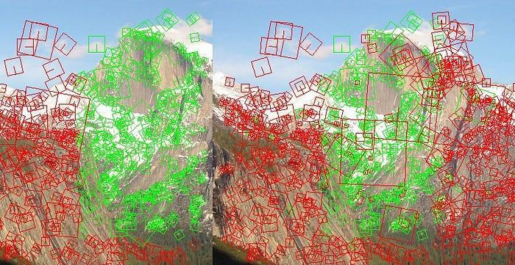

# **Feature**

A feature is a piece of information which is relevant for solving the computational task related to a certain application. Features may be specific structures in the image such as points, edges or objects. The features can be classified into two main categories:

* The features that are in specific locations of the images, such as mountain peaks, building corners, doorways, or interestingly shaped patches of snow. These kinds of localized features are often called **keypoint features** (or even corners) and are often described by the appearance of patches of pixels surrounding the point location.
* The features that can be matched based on their orientation and local appearance (edge profiles) are called **edges** and they can also be good indicators of object boundaries and occlusion events in the image sequence.

# **Main Component Of Feature Detection And Matching**

* **Detection:** Identify the **Interest Point**
* **Description:** The local appearance around each feature point is described in some way that is (ideally) invariant under changes in illumination, translation, scale, and in-plane rotation. We typically end up with a descriptor vector for each feature point.
* **Matching:** Descriptors are compared across the images, to identify similar features. For two images we may get a set of pairs (***Xi, Yi***) ↔ (***Xi`, Yi`***), where (***Xi, Yi***) is a feature in one image and (***Xi`, Yi`***) its matching feature in the other image.

# **Interest Point**

Interest point or Feature Point is the point which is expressive in texture. Interest point is the point at which the direction of the boundary of the object changes abruptly or the intersection point between two or more edge segments.

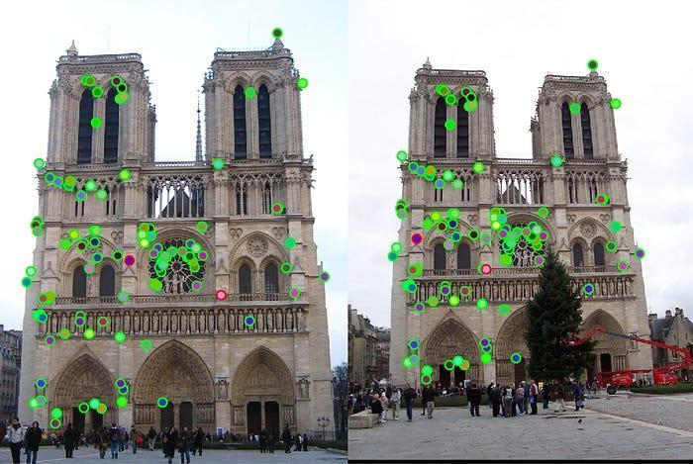

## **Properties Of Interest Point**

* It has a well-defined *position* in image space or well localized.
* It is *stable* under local and global perturbations in the image domain as illumination/brightness variations, such that the interest points can be reliably computed with a high degree of *repeatability*.
* Should provide efficient detection.

# **Feature Descriptor**

A feature descriptor is an algorithm which takes an image and outputs feature descriptors/feature vectors. Feature descriptors encode interesting information into a series of numbers and act as a sort of numerical “fingerprint” that can be used to differentiate one feature from another.

# 

# 

# **5.2.1 HOG:Histogram of Oriented Gradients**

The Histogram of Oriented Gradients (HOG) is a popular feature descriptor technique in computer vision and image processing. It analyzes the distribution of edge orientations within an object to describe its shape and appearance. The HOG method involves computing the gradient magnitude and orientation for each pixel in an image and then dividing the image into small cells.



The HOG descriptor focuses on the structure or the shape of an object. In the case of edge features, we only identify if the pixel is an edge or not. HOG is able to provide the edge direction as well. This is done by extracting the gradient and orientation (or you can say magnitude and direction) of the edges

The HOG would generate a Histogram for each of these regions separately. The histograms are created using the gradients and orientations of the pixel values, hence the name ‘Histogram of Oriented Gradients’

Process of Calculating the Histogram of Oriented Gradients (HOG)

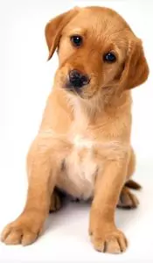 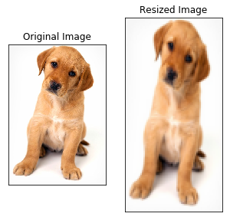

Consider the image of size (180 x 280).

Step 1: Preprocess the Data (64 x 128)

This is a step most of you will be pretty familiar with. Preprocessing data is a crucial step in any machine learning project and that’s no different when working with images.

We need to preprocess the image and bring down the width to height ratio to 1:2. The image size should preferably be 64 x 128. This is because we will be dividing the image into 8*8 and 16*16 patches to extract the features. Having the specified size (64 x 128) will make all calculations pretty simple.

Step 2: Calculating Gradients (direction x and y)

The next step is to calculate the gradient for every pixel in the image. Gradients are the small change in the x and y directions. Here, I am going to take a small patch from the image and calculate the gradients on that:

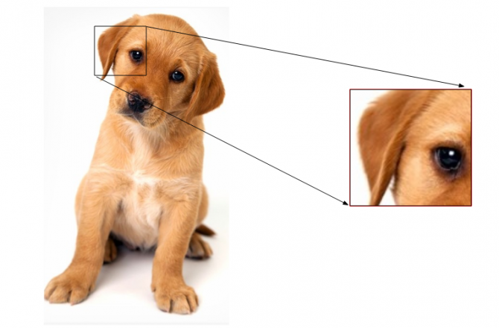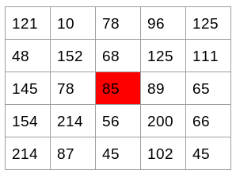

I have highlighted the pixel value 85. Now, to determine the gradient (or change) in the x-direction, we need to subtract the value on the left from the pixel value on the right. Similarly, to calculate the gradient in the y-direction, we will subtract the pixel value above from the pixel value below the selected pixel.

Hence the resultant gradients in the x and y direction for this pixel are:

Change in X direction(Gx) = 89 – 78 = 11

Change in Y direction(Gy) =56-68= -8

This process will give us two new matrices – one storing gradients in the x-direction and the other storing gradients in the y direction. This is similar to using a Sobel Kernel of size 1. The magnitude would be higher when there is a sharp change in intensity, such as around the edges.

We have calculated the gradients in both x and y direction separately. The same process is repeated for all the pixels in the image.

Step 3: Calculate the Magnitude and Orientation

Using the gradients we calculated in the last step, we will now determine the magnitude and direction for each pixel value.

So, for the previous example, we had Gx and Gy as 11 and -8.

Total Gradient Magnitude = √[(Gx)2+(Gy)2]= √[(11)2+(-8)2] = 13.6

Next, calculate the orientation (or direction) for the same pixel. Hence, the value of the angle would be:

Φ = atan(Gy / Gx)

The orientation comes out to be 36 when we plug in the values. So now, for every pixel value, we have the total gradient (magnitude) and the orientation (direction). We need to generate the histogram using these gradients and orientations.

Magnitude: 13.6 Φ: -36

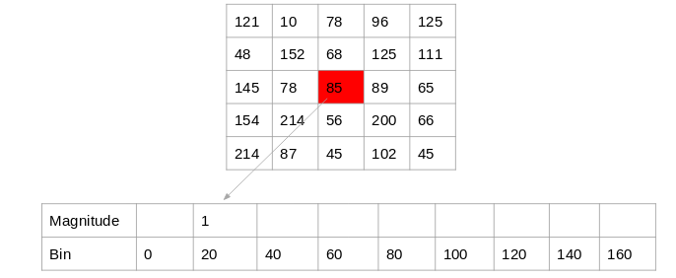

This method creates 0-20(20 degree) bins. So, the number of buckets we would get here is 9.

For each pixel, we will check the orientation, and store the frequency of the orientation values in the form of a 9 x 1 matrix. Plotting this would give us the histogram:

Step 4: Calculate Histogram of Gradients in 8×8 cells (9×1)

The histograms created in the HOG feature descriptor are not generated for the whole image. Instead, the image is divided into 8×8 cells, and the histogram of oriented gradients is computed for each cell.

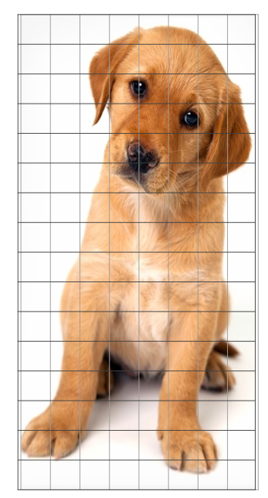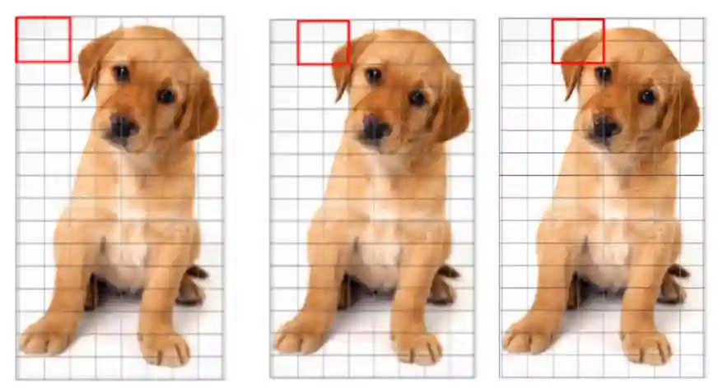

Step 4 Step 5

By doing so, we get the features (or histogram) for the smaller patches which in turn represent the whole image. This value can be changed here from 8 x 8 to 16 x 16 or 32 x 32.

If we divide the image into 8×8 cells and generate the histograms, we will get a 9 x 1 matrix for each cell. This matrix is generated using method 4 that we discussed in the previous section.

Once we have generated the HOG for the 8×8 patches in the image, the next step is to normalize the histogram.

Step 5: Normalize gradients in 16×16 cell (36×1)

The HOG features created for the 8×8 cells of the image, the gradients of the image are sensitive to the overall lighting. This means that for a particular picture, some portion of the image would be very bright as compared to the other portions.

We cannot completely eliminate this from the image. But we can reduce this lighting variation by normalizing the gradients by taking 16×16 blocks. Here is an example (in fig) that can explain how 16×16 blocks are created.

Here, we will be combining four 8×8 cells to create a 16×16 block. And we already know that each 8×8 cell has a 9×1 matrix for a histogram. So, we would have four 9×1 matrices or a single 36×1 matrix.

To normalize this matrix, we will divide each of these values by the square root of the sum of squares of the values. Mathematically, for a given vector V = [a1, a2, a3, ….a36]

We calculate the root of the sum of squares,And divide all the values in the vector V with this value k:

k = √(a1)2+ (a2)2+ (a3)2+ …. (a36)2  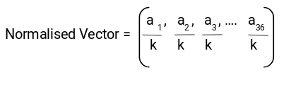

The resultant would be a normalized vector of size 36×1.

Step 6: Features for the complete image

We are now at the final step of generating HOG features for the image. So far, we have created features for 16×16 blocks of the image. Now, we will combine all these to get the features for the final image.

We would first need to find out how many such 16×16 blocks would we get for a single 64×128 image:

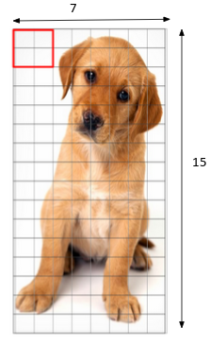

We would have 105 (7×15) blocks of 16×16. Each of these 105 blocks has a vector of 36×1 as features. Hence, the total features for the image would be 105 x 36×1 = 3780 features.

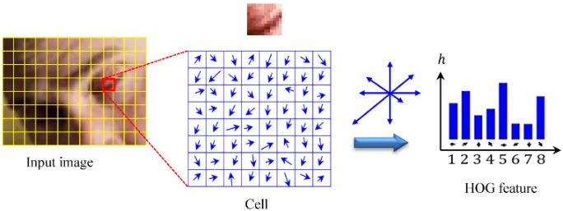

| import cv2  import numpy as np  from skimage.feature import hog  import matplotlib.pyplot as plt  # Load the image (convert to grayscale for HOG)  image = cv2.imread('example.jpg', cv2.IMREAD_GRAYSCALE)  # Resize the image for consistent feature extraction  resized_image = cv2.resize(image, (128, 64)) # Standard size for HOG (e.g., 128x64 for person detection)  # Compute HOG features  hog_features, hog_image = hog(  resized_image,  orientations=9,  pixels_per_cell=(8, 8),  cells_per_block=(2, 2),  visualize=True,  )  # Display the original image and the HOG visualization  plt.figure(figsize=(12, 6))  # Original image  plt.subplot(1, 2, 1)  plt.title('Original Image')  plt.imshow(resized_image, cmap='gray')  # HOG visualization  plt.subplot(1, 2, 2)  plt.title('HOG Features')  plt.imshow(hog_image, cmap='gray')  plt.show() |
| --- |

**Calculate normalize histogram for given HOG orientation.**

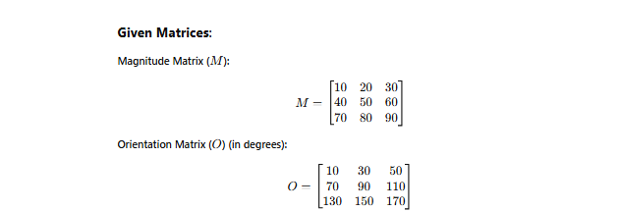

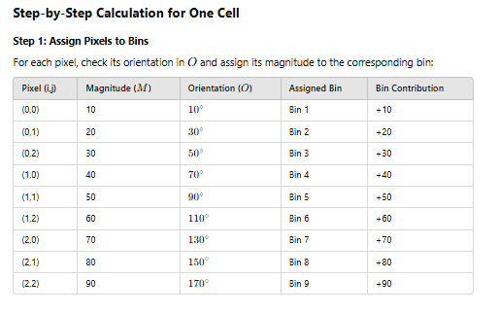

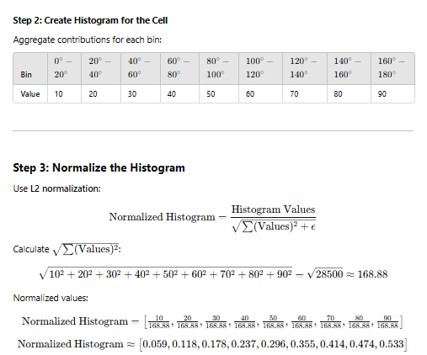

# **5.2.2 SIFT:Scale-Invariant Feature Transform**

SIFT stands for Scale-Invariant Feature Transform and was first presented in 2004, by D.Lowe, University of British Columbia. SIFT is invariance to image scale and rotation. This algorithm is patented, so this algorithm is included in the Non-free module in OpenCV.

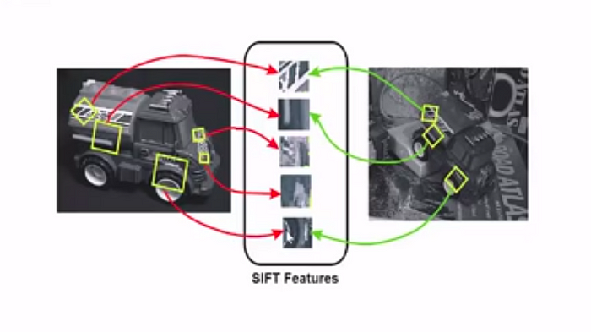

Major advantages of SIFT are

* **Locality:** features are local, so robust to occlusion and clutter (no prior segmentation)
* **Distinctiveness:** individual features can be matched to a large database of objects
* **Quantity:** many features can be generated for even small objects

### Applications of SIFT in Computer Vision: SIFT is used in image matching, object detection, and scene recognition. It locates keypoints that are invariant to size and orientation, making them useful for various computer vision tasks.

### **Example Demonstration**

For instance, matching keypoints of the Eiffel Tower in a large image with those in a smaller or rotated version demonstrates how SIFT can handle changes in scale and orientation.

### **The SIFT Process**

SIFT operates in four main steps:

1. Constructing Scale Space: Create images at different scales to make the features scale-independent.

To remove noise and ensure features are scale-invariant, Gaussian Blur is applied. It reduces the image's details while preserving essential features.

Gaussian Blur smooths the image, helping highlight important features by reducing noise.

A Scale Space is created by generating multiple blurred versions of the image at different scales.Here is an example to understand it in a better manner. We have the original image of size (275, 183) and a scaled image of dimension (138, 92). For both images, two blur images are created:

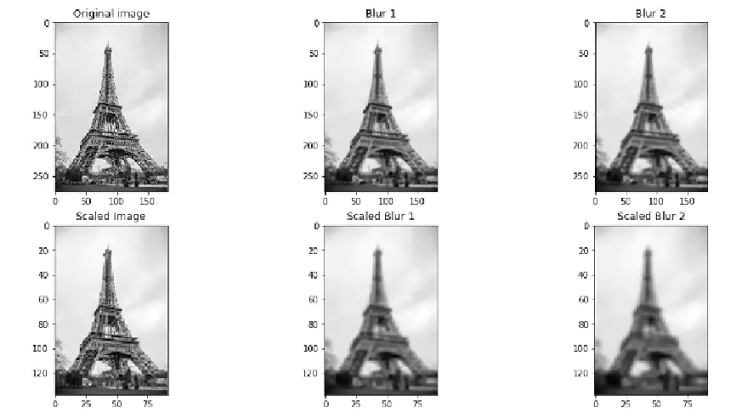You might be thinking – how many times do we need to scale the image, and how many subsequent blur images need to be created for each scaled image? The ideal number of octaves should be four, and for each octave, the number of blur images should be five.

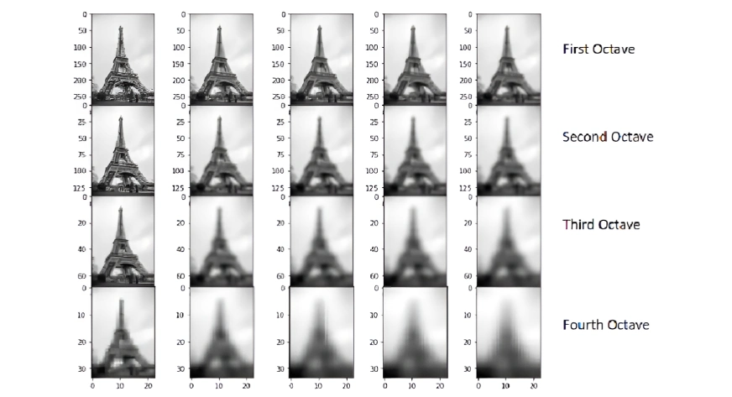

### **Difference of Gaussians**

To enhance features, the Difference of Gaussians (DoG) subtracts a blurred image from another with a lower blur level, emphasizing distinct features.

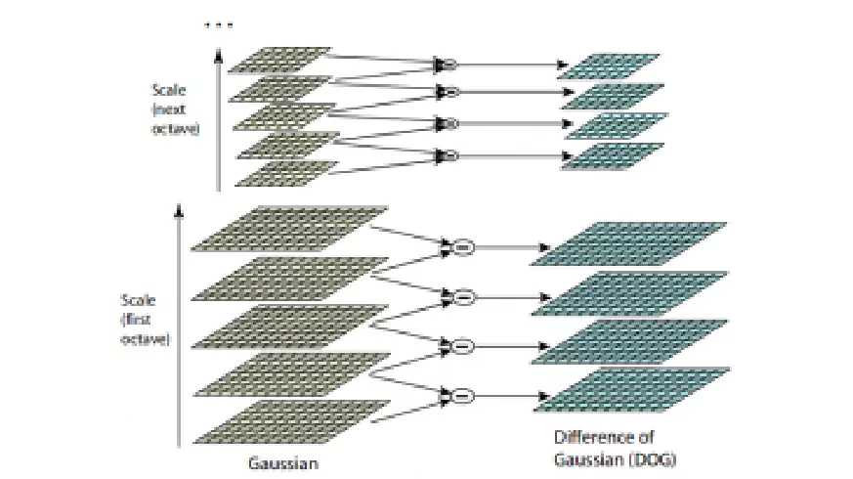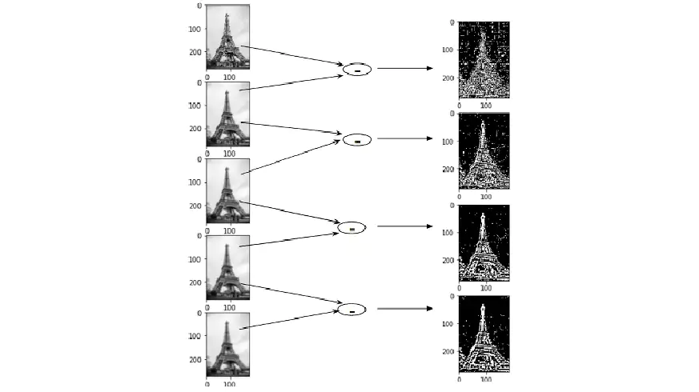

1. Keypoint Localization: Find keypoints by identifying local maxima and minima. Keypoints are found by identifying local maxima and local minima after the DoG operation. Pixels are compared with their neighbors to detect these extrema.

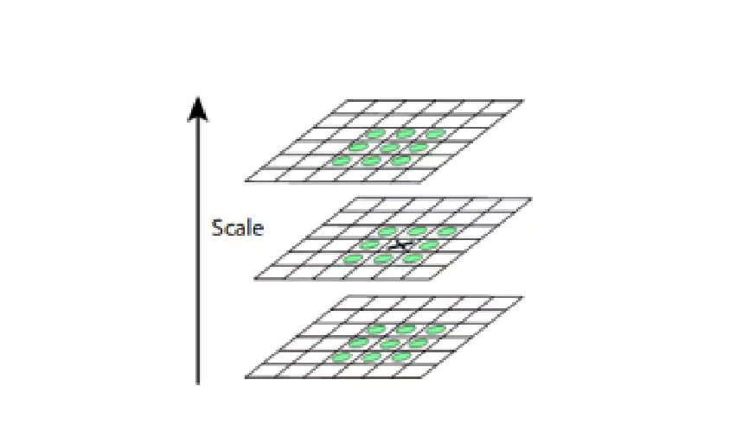

1. Keypoint Selection/detection: Low-contrast or edge-adjacent keypoints are eliminated to ensure robustness.These are the key points that are close to the edge and have a high edge response but may not be robust to a small amount of noise. A second-order Hessian matrix is used to identify such keypoints.

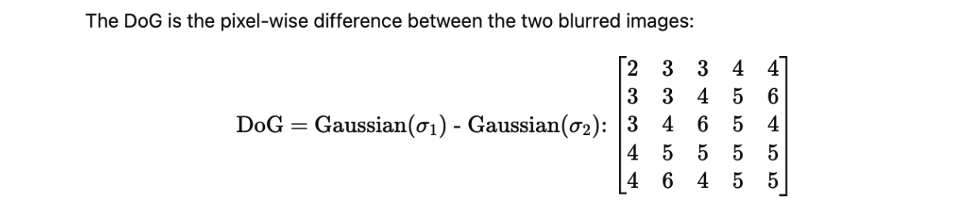

# 

# 

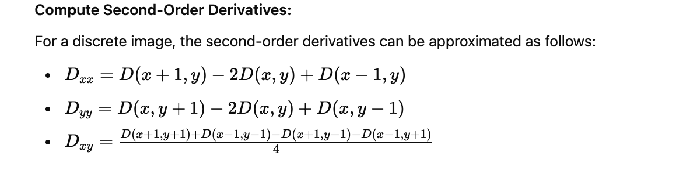

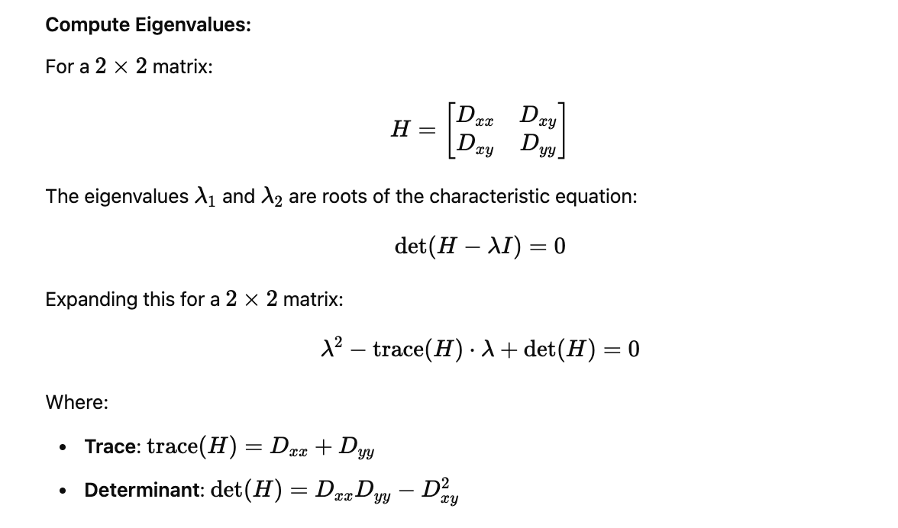

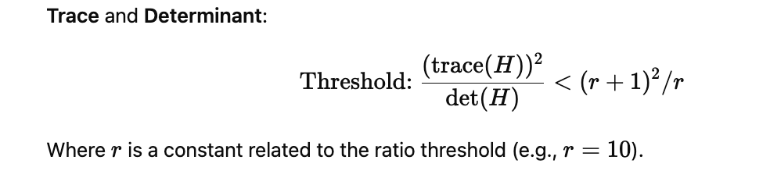

Here in example we consider (r+1)2/r=10

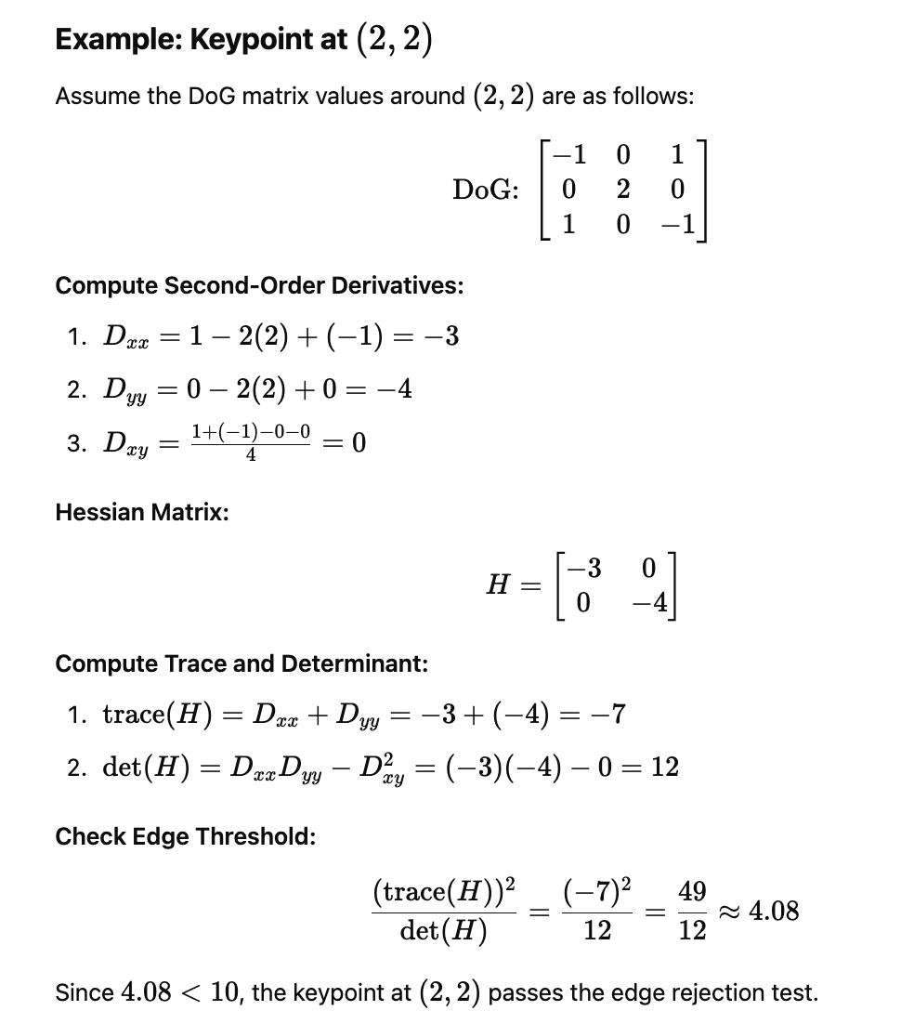

1. Orientation Assignment: Make keypoints rotation-invariant.

For rotation invariance, each keypoint is assigned an orientation based on the gradient of the image. A histogram of gradient directions is created, and the dominant peak defines the orientation.

At this stage, we have a set of stable keypoints for the images. We will now assign an orientation to each of these keypoints so that they are invariant to rotation. We can again divide this step into two smaller steps:

1. Calculate the magnitude and orientation
2. Create a histogram for magnitude and orientation

### 1.Calculate Magnitude and Orientation

Consider the sample image shown below:

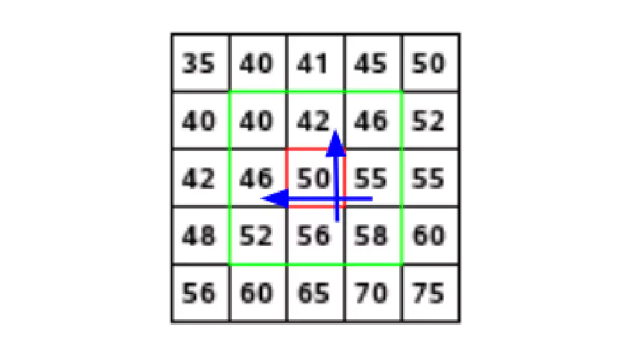

Let’s say we want to find the magnitude and orientation for the pixel value in red. For this, we will calculate the gradients in the x and y directions by taking the difference between 55 & 46 and 56 & 42. This comes out to be Gx = 9 and Gy = 14, respectively.

Once we have the gradients, we can find the magnitude and orientation using the following formulas:

Magnitude = √[(Gx)2+(Gy)2] = 16.64

Φ = atan(Gy / Gx) = atan(1.55) = 57.17

The magnitude represents the intensity of the pixel and the orientation gives the direction for the same.

We can now create a histogram given that we have these magnitude and orientation values for the pixels.

### 2.Creating a Histogram for Magnitude and Orientation

On the x-axis, we will have bins for angle values, like 0-9, 10 – 19, 20-29, and up to 360. Since our angle value is 57, it will fall in the 6th bin. The 6th bin value will be in proportion to the magnitude of the pixel, i.e. 16.64.

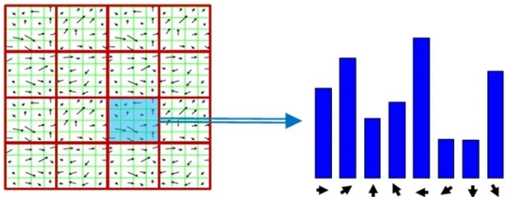

This histogram would peak at some point. The bin at which we see the peak will be the orientation for the keypoint.

1. Keypoint Descriptor: Assign a unique descriptor to each keypoint.

This is the final step for SIFT(scale invariant feature transform) computer vision. So far, we have stable keypoints that are scale-invariant and rotation-invariant. In this section, we will use the neighboring pixels, their orientations, and their magnitude to generate a unique fingerprint for this keypoint called a ‘descriptor’.

Additionally, since we use the surrounding pixels, the descriptors will be partially invariant to the illumination or brightness of the images.

To do this, a 16x16 window around the keypoint is taken. It is divided into 16 sub-blocks of 4x4 size.For each sub-block, 8 bin orientation histogram is created.

So 4 X 4 descriptors over 16 X 16 sample array were used in practice. 4 X 4 X 8 directions give 128 bin values. It is represented as a feature vector to form keypoint descriptor. This feature vector introduces a few complications. We need to get rid of them before finalizing the fingerprint.

# 

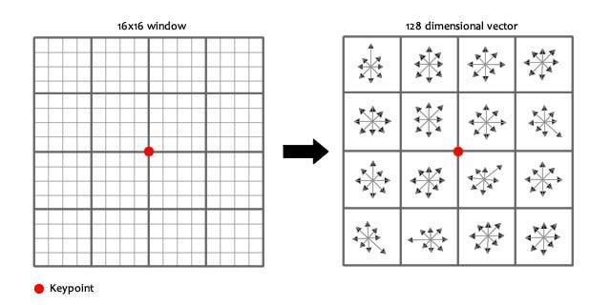

# 

# 

# [**https://medium.com/@deepanshut041/introduction-to-sift-scale-invariant-feature-transform-65d7f3a72d40**](https://medium.com/@deepanshut041/introduction-to-sift-scale-invariant-feature-transform-65d7f3a72d40)

# 

# 

# 

# 

# 

# 

# 

# **5.3 Features Matching**

Features matching or generally image matching, a part of many computer vision applications such as image registration, camera calibration and object recognition, is the task of establishing correspondences between two images of the same scene/object. A common approach to image matching consists of detecting a set of interest points each associated with image descriptors from image data. Once the features and their descriptors have been extracted from two or more images, the next step is to establish some preliminary feature matches between these images.

Feature matching is a fundamental technique in computer vision that allows us to find corresponding points between two images. It works by detecting distinctive key points in each image and comparing their descriptors, which represent the unique characteristics of these key points. By matching the descriptors in both images, we can establish correspondences and identify similar objects or scenes in different images.

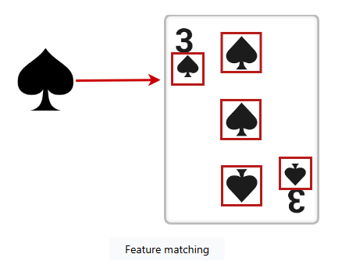

<https://medium.com/@nikhilnair8490/2d-feature-tracking-part-3-feature-matching-72a1bc8dc58a>

<https://www.kaggle.com/code/faruqaziz/image-matching-sift-algorithm>

Feature matching using **FLANN** (Fast Library for Approximate Nearest Neighbors) and **Brute Force** are commonly used in Computer Vision for finding corresponding points between two images based on feature descriptors like SIFT, SURF, or ORB. Below is a step-by-step explanation with a numerical example

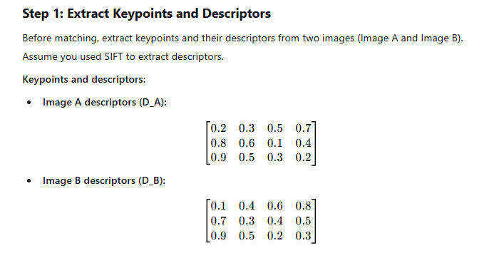

**5.3.1 Brute force Matcher:**

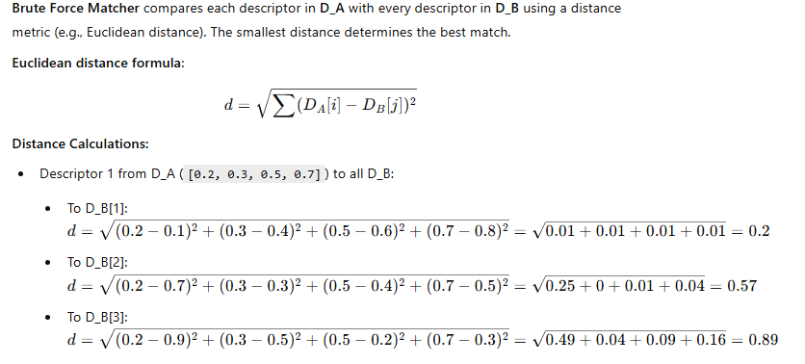

**5.3.2 FLANN Matcher:**

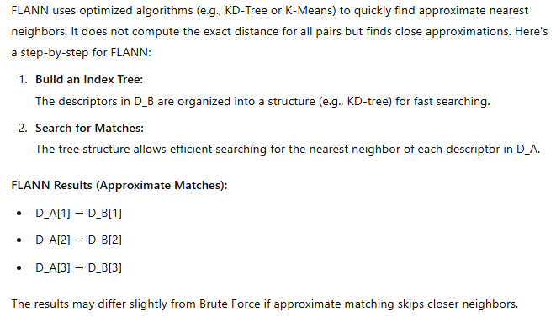

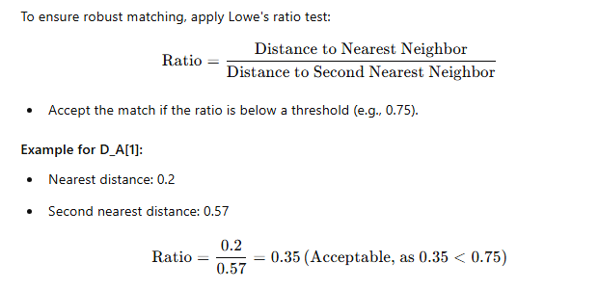

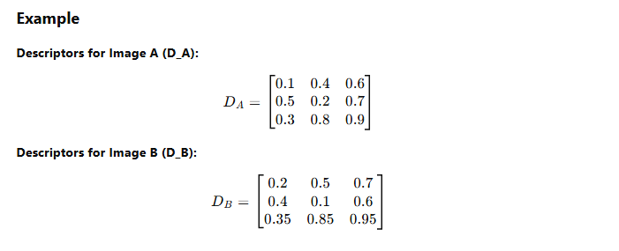

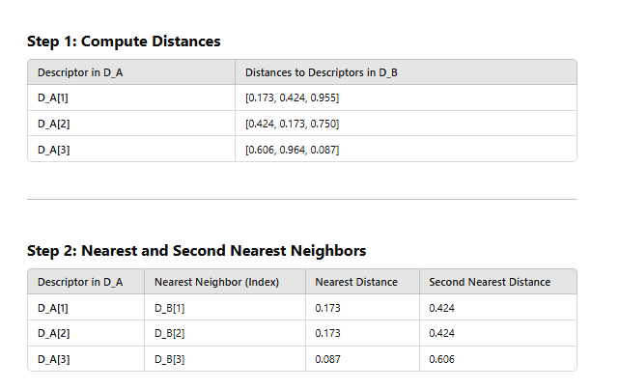

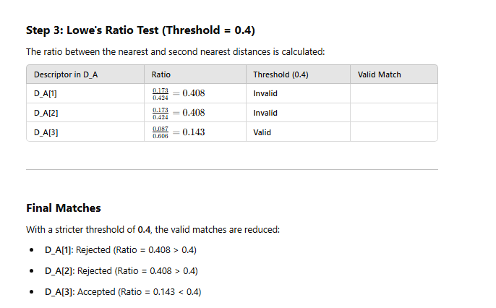

| **# Load images**  **img1 = cv2.imread('image1.jpg', cv2.IMREAD_GRAYSCALE)**  **img2 = cv2.imread('image2.jpg', cv2.IMREAD_GRAYSCALE)**  **# Initialize SIFT detector**  **sift = cv2.SIFT_create()**  **# Detect keypoints and compute descriptors**  **keypoints1, descriptors1 = sift.detectAndCompute(img1, None)**  **keypoints2, descriptors2 = sift.detectAndCompute(img2, None)**  **# FLANN parameters**  **FLANN_INDEX_KDTREE = 1**  **index_params = dict(algorithm=FLANN_INDEX_KDTREE, trees=5)**  **search_params = dict(checks=50)**  **# Create FLANN matcher**  **flann = cv2.FlannBasedMatcher(index_params, search_params)**  **# Match descriptors**  **matches = flann.knnMatch(descriptors1, descriptors2, k=2)**  **# Store good matches**  **good_matches = []**  **for m, n in matches:**  **if m.distance < 0.7 * n.distance:**  **good_matches.append(m)**  **# Draw matches**  **matched_image = cv2.drawMatches(img1, keypoints1, img2, keypoints2, good_matches[:10], None, flags=cv2.DRAW_MATCHES_FLAGS_NOT_DRAW_SINGLE_POINTS)**  **# Show results**  **cv2.imshow('FLANN Matches', matched_image)**  **cv2.waitKey(0)**  **cv2.destroyAllWindows()** |
| --- |